Topic: Django Signals

**Question 1: By default are django signals executed synchronously or asynchronously?**

By default, Django signals are executed synchronously. This means that when a signal is sent, the execution of the code is blocked until all receivers have finished processing the signal.

**Code Snippet**

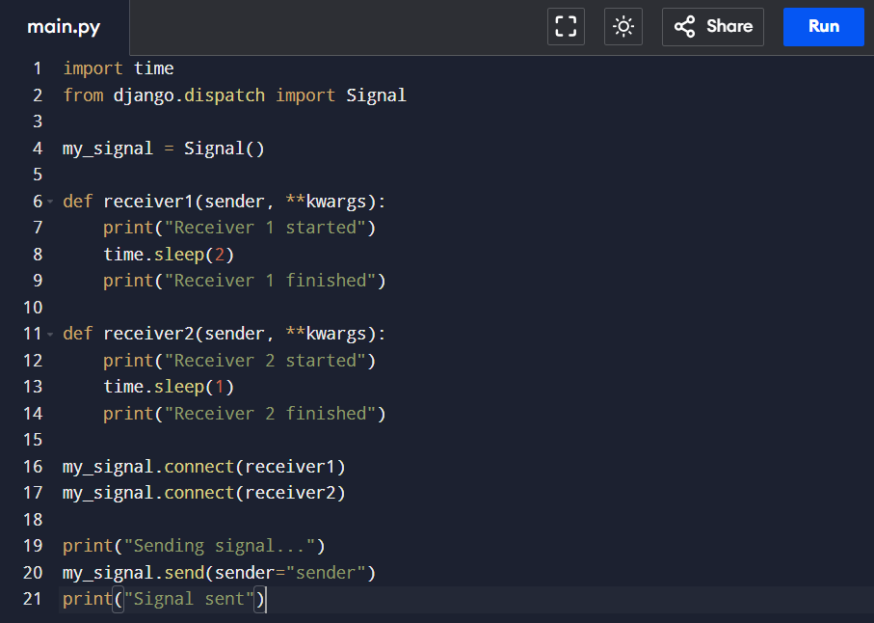

**Output:**

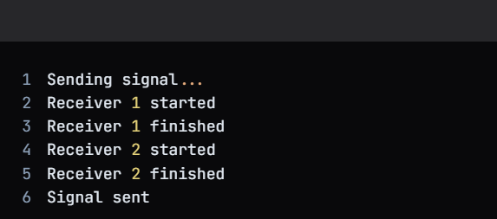

**Question 2: Do django signals run in the same thread as the caller?**

Yes, Django signals run in the same thread as the caller. This means that when a signal is sent, the receivers are executed in the same thread as the code that sent the signal.

**Code Snippet**

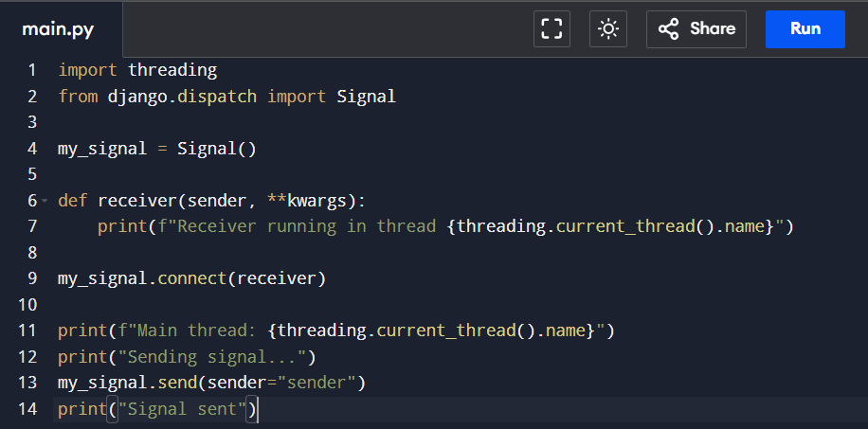

**Output:**

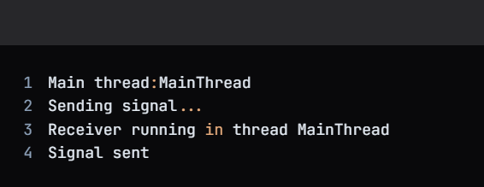

**Question 3: By default do django signals run in the same database transaction as the caller?**

Yes, Django signals run in the same database transaction as the caller. This means that if a signal is sent within a database transaction, the receivers will also run within the same transaction.

**Code Snippet**

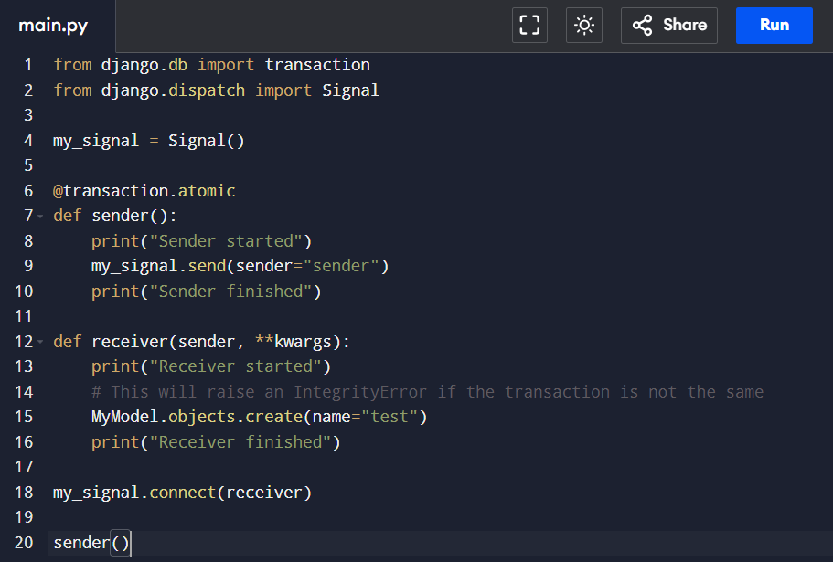

**Output:**

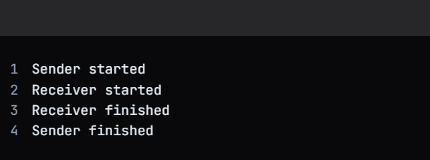

Topic: Custom Classes in Python

**Description:** You are tasked with creating a Rectangle class with the following requirements:

1. An instance of the Rectangle class requires length:int and width:int to be initialized.
2. We can iterate over an instance of the Rectangle class

When an instance of the Rectangle class is iterated over, we first get its length in the format: **{'length': <VALUE_OF_LENGTH>}** followed by the width **{width: <VALUE_OF_WIDTH>}**

**Code Snippet**

